Step 1: Log in this link : http://i.njupt.edu.cn/cas/login?service=http%3A%2F%2Fi.njupt.edu.cn%2Fportal%2Fcas%2Fclient%2FvalidateLogin

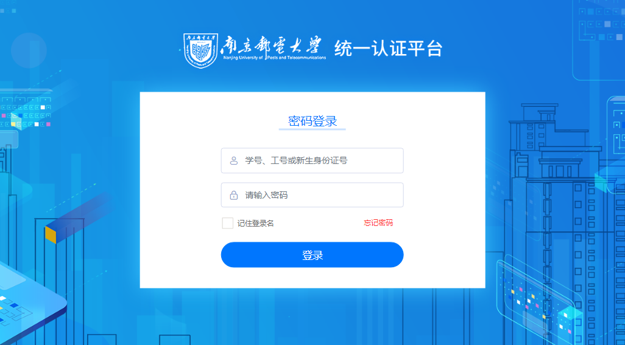

Account: Your Student ID

Pw: Lxs_(last six digit of passport number)

If you have problem with you password, please contact at tel:025-83492019 or e-mail:xxh@njupt.edu.cn

Step2 : click “研究生系统”

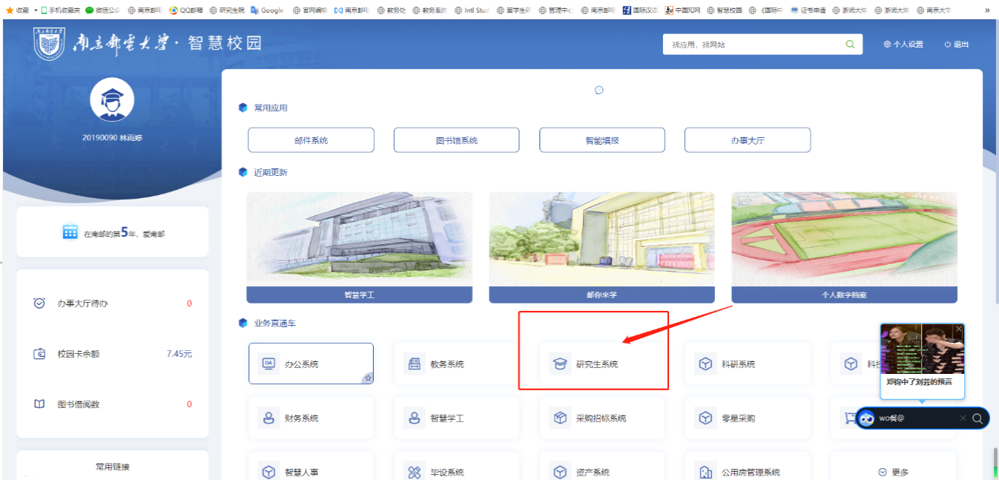

Step 3 : click“培养”，and click “培养过程”，then click “开题报告”. You need to check the information in this page, and fill in your thesis open report information.

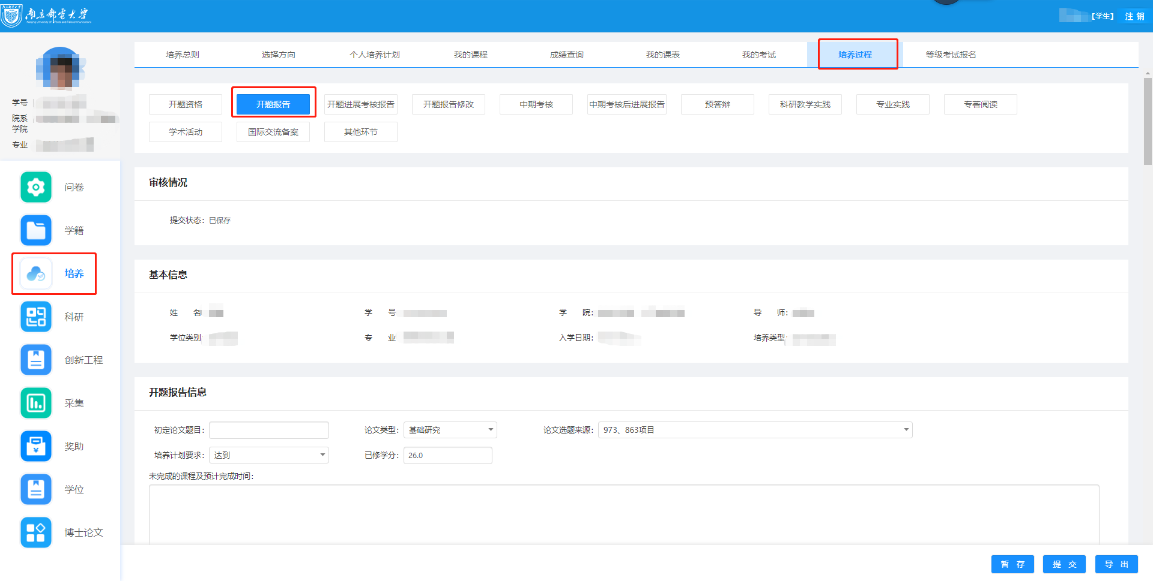

Step4: After filling in the thesis open report information, export the WORD version of the report and the thesis open test form in the lower right corner, convert the PDF version of the report and upload it.

Step 5: In the process of data filling and input, you can click "暂存" to save the data; After all data is entered completely and confirmed, be sure to click "提交" ，then display successful saving.

Step6:Graduate students with mid-term examination grade C or D are required to complete the progress report after the mid-term examination under the supervision of the supervisor or the college.

Situation 1: Students can modify the relevant content of the thesis open report without the review of the supervisor, and click "提交" and "确认" again after modification.

Situation 2: After the supervisor or college passes the audit, students cannot modify the submitted mid-term examination content. If you want to modify it, you need to ask supervisor to "revoke" the audit result on the supervisor or college side, and you can modify it in the student side . After the modification is completed, click "提交" and "确定" ,then display that the saving is successful, and the supervisor or college port can be reviewed again.

If you have any problem during the use of the system, please contact the Office of Graduate School in time, Tel: 025-83492352, email: yxw@njupt.edu.cn. If you have any problem, please consult by email.